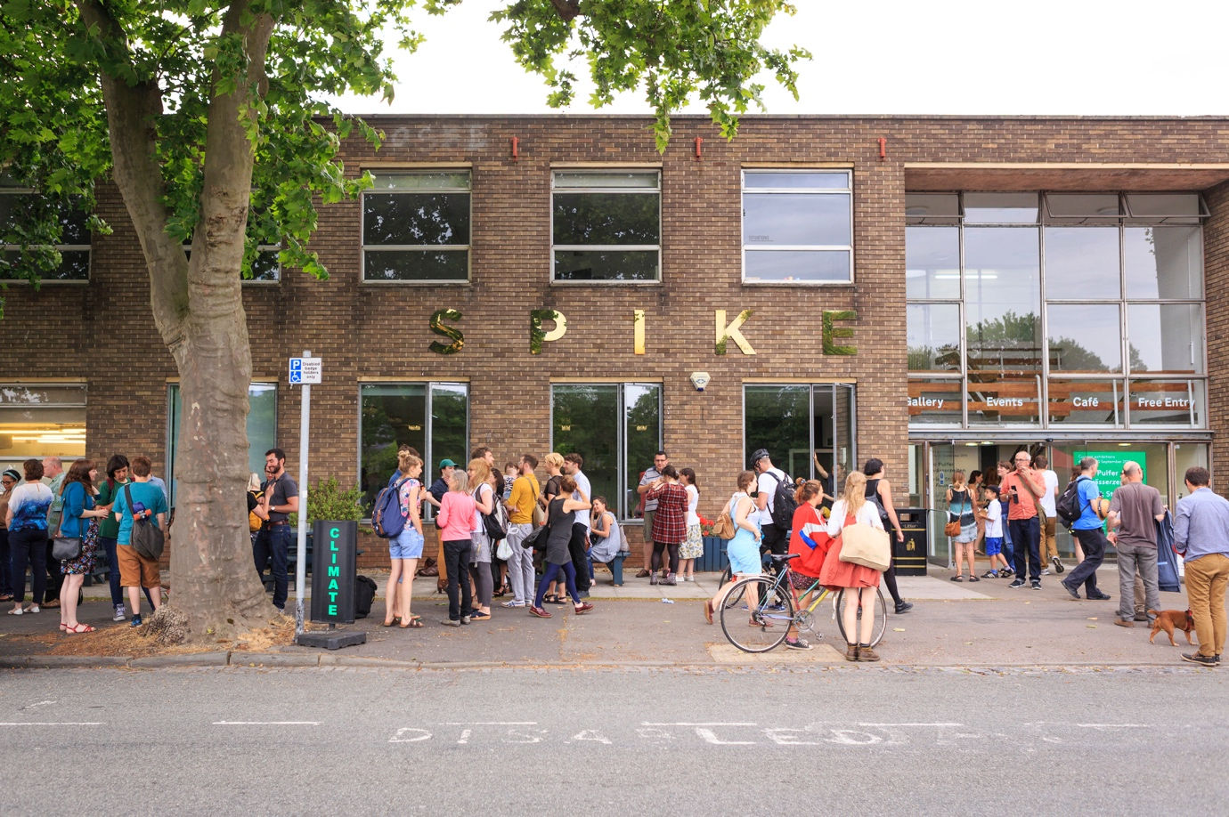

Image: Spike Island exterior. Photograph Max McClure

**UWE Bristol / Spike Island Associates Membership Bursary Application Form**

As a soon-to-graduate student of a creative degree at UWE Bristol, you have the opportunity to apply for our Spike Island Associates Membership Bursary.

**WHAT IS SPIKE ISLAND?**

Spike Island is an international centre for the development of contemporary art and design. It is a place where artists and the public can meet, enabling audiences to engage with artists’ research and production. Spike Island offers visitors a year-round programme of internationally relevant exhibitions, events and activities, as well as providing working space for artists, designers and creative businesses. [Find out more](https://www.spikeisland.org.uk/plan-your-visit/about/)

**WHAT IS SPIKE ISLAND ASSOCIATES?**

Spike Island Associates is a network that offers professional development opportunities and events to artists, curators, designers and writers who are keen to collaborate and experiment with all forms of art. Members are active contributors to a diverse network and can support one another with ambitious projects, working individually or together to develop their own creative practice. [Find out more](https://www.spikeisland.org.uk/our-community/spike-island-associates/)

**WHAT IS THE BURSARY?**

The standard Spike Island Associates membership fee is normally £12 per month.

UWE Bristol are offering to pay membership fees to the Spike Island Associates network for 12 months (a value of £144) for ten UWE Bristol graduates.

**WHAT DOES A MEMBERSHIP INVOLVE?**

As a member, you are encouraged to develop your own creative work and professional skills through practical workshops. A year-round programme of events, opportunities and projects is offered exclusively to members, including crit sessions with visiting artists from around the world. Spike Island Associates membership includes the following:

* Free admission to most of Spike Island’s talks and events
* 24-hour access to shared working space, featuring: IT facilities such as wireless internet, scanning, printing and computers with Adobe Suite, graphics and video editing software; a reference library including artists’ monographs, critical theory texts and art periodicals; and an active noticeboard for local, regional and national exhibitions, events and opportunities.
* Regular events, workshops, peer crits and one-to-one sessions with guest artists and curators
* Occasional group trips, with subsidised travel when possible
* The UWE Bristol / Spike Island Associates Membership Bursaries are valid for the 2024 intake from 30 September 2024 – 30 September 2025

**CRITERIA**

Applicants should be graduating from a UWE Bristol Schools of Arts undergraduate programme (listed below) in 2024:

Fine Art

Art & Writing

Illustration

Graphic Design

Fashion Communication

Fashion Textiles

Interior Design

Photography

Filmmaking

Animation

Creative and Professional Writing

Product Design

Drama & Acting

The panel (comprising a member of staff from UWE Bristol and a member of staff from Spike Island) will select successful applicants using the following criteria:

* Demonstration of a commitment to creative practice.
* A clear understanding of how membership will enhance their professional practice.
* Clear articulation of a commitment to the city and / or region.
* The achievements of the applicant to date.

Successful applicants are expected to:

Complete a short, written evaluation when their membership ends comparing their progress against the original objectives outlined in their application form, as well as providing feedback to enable effective evaluation of the scheme.

**APPLYING**

Applications are to be submitted **via** [**this link**](https://www.spikeisland.org.uk/our-community/spike-island-associates/uwe-bristol-spike-island-associates-membership-bursary-application-2024/) **by** **Wednesday 26 June 2024, 9am**.

**UWE Bristol / Spike Island Associates Membership**

**Application Form**

1. **Personal details**

|  |  |  |  |
| --- | --- | --- | --- |
| First name |  | Surname |  |
| Address |  | | |
| Phone |  | Mobile |  |
| Personal email |  | | |
| UWE email |  | | |
| Website |  | | |
| UG UWE degree programme |  | | |
| Degree classification |  | | |

1. **Personal Statement**

Please provide a short statement (up to a maximum of 400 words in total) on:

* An introduction to your practice, experience and key areas of interest
* What contribution you could make and what you would hope to gain from membership
* How this opportunity will enhance your professional development

1. **Images and media**

If relevant to your practice, please provide a link to your work on your website or social media, or attach up to five digital images of your work at 300dpi in the format:

ArtistName_TitleOfWork.jpg (eg. EdvardMunch_TheScream.jpg)

1. **Sign and date**

I declare that the information I have given in this application form is, to the best of my knowledge, true and correct.

Signature Date / /

Please name your completed application form: *Your Name_UWE Spike Associates Bursary Application*

Submit your completed application form and an equal opportunities monitoring form via **this link** by **Wednesday 26 June, 9am**: <https://www.spikeisland.org.uk/our-community/spike-island-associates/uwe-bristol-spike-island-associates-membership-bursary-application-2024/>

Successful applicants will be notified by Monday 1 July 2024.