PRESS RELEASE  
[CANDICE LIN](https://www.spikeisland.org.uk/programme/exhibitions/candice-lin/)  
*PIGS AND POISON*  
5 February to 8 May 2022

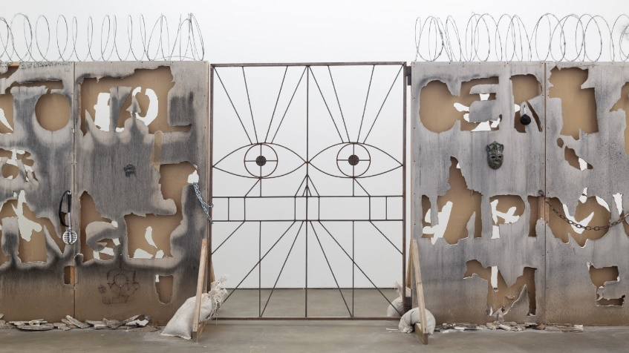  
  
Spike Island presents *Pigs and Poison*, a major new commission by LA-based artist Candice Lin that expands her ongoing research into marginalised histories, colonial legacies and the materials that link them. Combining materials as diverse as opium poppy, bone black pigment and lard, the exhibition weaves together wide-ranging stories of migration, biological warfare, and British and American colonial relationships with China to explore how Asian people have often been defined in relationship to animality, contagion, and the inhuman. Lin traces how these definitions have subsequently influenced constructions of whiteness and citizenship in the United States.

The title of Lin’s exhibition refers to the trade in Chinese indentured labourers (disparagingly known as ‘pigs’) and opium (poison) during the nineteenth century. This period brought about the two Opium Wars that marked the start of an era of unequal treaties between China and foreign imperialist powers, including strict immigration laws that eventually led to the 1882 Chinese Exclusion Act in the United States: the first law to disallow immigration on the basis of race, regardless of nationality.

The centrepiece of *Pigs and Poison* is a monumental trebuchet that launches cannonballs made of lard and bone black pigment at the gallery walls. This work references an early example of biological warfare: the 1346 siege of Caffa (now Feodosia, Crimea), when the attacking Mongol army catapulted the plague-infected corpses of people and horses inside the city walls. When the siege broke, the people who fled the city with their lives supposedly first brought the plague to Europe. Purring, flesh-like sculptures reference the plague-ridden Mongol corpses and accompany a series of small-scale lard paintings highlighting plague outbreaks in San Francisco and Honolulu at the turn of the twentieth century, for which Chinese citizens were held responsible and subsequently victimised.

The viscous cannonballs soar over a roughshod barricade topped with barbed wire that divides the main gallery space, creating an encrusted, blue-black painting on the wall. Carved into the border is the phrase “meaningless squiggles” in both English and Mandarin, translated via Google Translate and drawn in Lin’s dad’s calligraphy. The phrase is taken from American Philosopher John Searle’s 1980 essay ‘Minds, Brains and Programs’, in which he first developed to so-called ‘Chinese room’ theory to distinguish, via his own inability to understand Mandarin, between AI and human consciousness. This work references the long history of Asiatic otherness being associated with a robotic lack of humanity or emotion, as well as exploring how cultural signifiers often fade or shift over time within diasporic communities.

As the world grapples with closing borders, lockdowns, the ongoing COVID-19 pandemic and a rise in racial tensions, Lin’s exhibition has an uncanny relevance in the UK today. In our short-sighted fight to control and contain, we lose track of how the connections between race, labour and illness have shaped continents, hierarchies and histories for many centuries.

– Ends –

Image: Candice Lin, *A Robot Spoke What My Father Wrote* (2019), Cut sheetrock, razor wire, bone black pigment and mould, ceramic, welded gate, miscellaneous drawings and printed material. Courtesy the artist and François Ghebaly, Los Angeles

For further information and high-resolution images please contact Jane Faram, Communications Manager at Spike Island on [jane.faram@spikeisland.org.uk](mailto:jane.faram@spikeisland.org.uk) or +44 (0)117 9292266.

NOTES FOR EDITORS

* CANDICE LIN  
  Candice Lin (b. 1979, Concord, Massachusetts) works in Los Angeles, California. She received her BA in Visual Arts and Art Semiotics from Brown University, in 2001, and MFA in New Genres from San Francisco Art Institute, in 2004. Her practice utilises installation, drawing, video, and living materials and processes, such as mould, mushrooms, bacteria, fermentation, and stains. She addresses themes of race, gender, and sexuality in relationship to material histories of colonialism, slavery, and diaspora. Lin has had recent solo exhibitions at the Walker Art Center, Minneapolis; Kunsthalle Osnabrück, Germany; Louisiana State University Museum of Art, New Orleans (all 2021); Pitzer Galleries, Claremont, CA; Walter Phillips Gallery, Banff Art Center, Canada; Ludlow 38, New York; Francois Ghebaly, Los Angeles, (all 2019) as well as the exhibition cycle *A Hard White Body*at Bétonsalon, Paris (2017); Portikus, Frankfurt; and the Logan Center for the Arts, University of Chicago (both 2018). Lin has been included in recent group exhibitions and biennials at the ICA, London; Para Site, Hong Kong; Beirut Art Center (all 2019); the Taipei Fine Arts Museum; Hammer Museum, Los Angeles (both 2018); Moderna Museet, Stockholm (2017); the New Museum, New York, and SculptureCenter New York (all 2017). She is the recipient of several residencies, grants and fellowships, including the Joan Mitchell Painters and Sculptors Grant (2019), The Artists Project Award (2018), Louis Comfort Tiffany Award (2017), the Davidoff Art Residency (2018) and Smithsonian Artist Research Fellowship (2009). She is Assistant Professor of Art at UCLA.
* The exhibition is accompanied by a richly illustrated catalogue designed by Cecilia Serafini, with contributions from Jih-Fei Cheng, Robert Leckie, Lisa Lowe and Shani Mootoo, as well as a conversation between the artist and Alvin Li.
* PARTNERS AND SUPPORTERS  
  *Pigs and Poison* is commissioned by Spike Island, Bristol; Govett-Brewster Art Gallery, New Plymouth and Guangdong Times Museum; and is part of the West of England Visual Arts Alliance programme, supported by Arts Council England.
* ABOUT SPIKE ISLAND  
  Spike Island supports, produces and presents contemporary art and culture across an 80,000 square foot former industrial building in Bristol. Its diverse artistic programme includes free major exhibitions, events and engagement activities taking place on-site and online. Championing outstanding work by emerging and underrepresented local, national and international artists, the programme enhances access to contemporary art for audiences from all backgrounds.

Alongside its public offer, Spike Island directly supports artists through new commissions, over 70 subsidised studios, and sector-leading artist development opportunities that widen access to its programme and facilities. Its Exhibition Services business supports the bespoke production and installation of artists’ film and video throughout the UK and internationally. Spike Island is home to a dynamic community of hundreds of artists and creative businesses, working in flexible, affordable workspaces, alongside UWE Bristol’s Fine Art department, Spike Print Studio, and café bar Emmeline.

[www.spikeisland.org.uk](http://www.spikeisland.org.uk)

