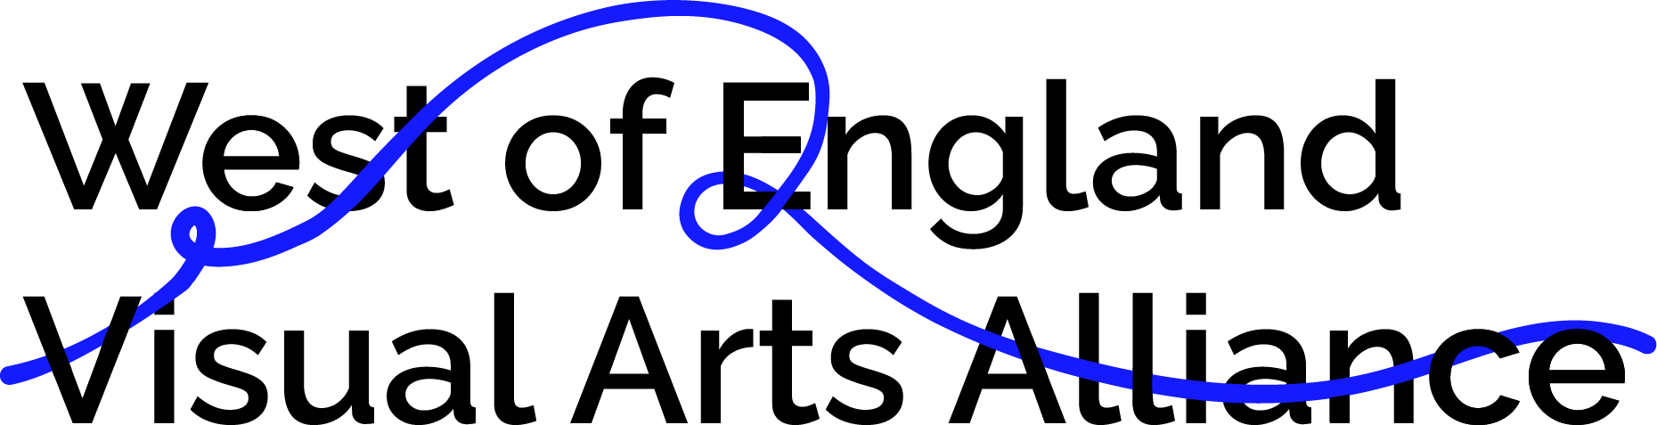

OPEN CALL
Research and Development Bursaries

Over the next three years, the West of England Visual Arts Alliance (WEVAA) aims to transform Bristol and the West of England into a place where the visual arts can thrive, providing critical opportunities and support to enable diverse local artists, curators and young people to develop their careers and achieve their potential.

WEVAA is invested in supporting exceptional visual arts projects to grow, across the West of England region. All partners are committed to inclusivity and developing more equitable practices. We consider diversity a strength and are keen to ensure more representation of the different backgrounds and experiences that make up our communities.

We particularly welcome applications from people who are currently underrepresented in the UK arts sector, including those who identify as D/deaf, disabled, neurodivergent, LGBTQIA+, those from lower socio-economic backgrounds or living or working in areas of socio-economic deprivation, and those who experience racism.

WEVAA will award three Research and Development Fellowships of £10,000, and 12–17 Research and Development Bursaries ranging from £500-£1,000 each. These will be selected from an open application process each year across the three years of the programme.

About the Research and Development Bursaries

We will award 12–17 Research and Development Bursaries to artists over the next three years, ranging from £500–£1,000 each. The bursaries are available to develop ideas in your art practice and can be used for research, travel, materials and any other costs related to the development of your work. The panel are looking for you to clearly evidence how these costs are critical to the development of new work and opportunities.
How to apply
Applications should be submitted as a single PDF document (under 10MB) via the form here. This PDF should include:
- Tell us why a Bursary is critical for you to develop new work and opportunities (up to 750 words). We are happy to accept video and audio versions. 750 words is approximately 6-7 minutes speaking time. Private YouTube links can be used to submit these.
- Include a CV of the primary applicants and also website links and supporting documentation of 4 pages max. This can also include a brief biography.
- Include your postcode and geographic location - we only accept postcodes in the areas of Bristol, South Gloucestershire, Bath and North East Somerset, and North Somerset.
- Your access document (if applicable)
You will be asked to complete an anonymous equal opportunities form following submission of your application (used for monitoring purposes only).
We realise that text-based applications do not suit everyone, so if you would like to apply in a different way, for example via video or audio, or require this information in a different format, please get in touch with us by writing to Graham Johnson, Online Programme Producer, Visual Arts South West, at graham@vasw.org.uk or by calling Spike Island Reception at 0117 929 2266. We want to remove as many barriers to applying as we can.
DEADLINE TO APPLY: Tuesday 11 January 2022 at 23:59 GMT
Please note that due to limited capacity, we are only able to respond directly to candidates who are invited to interview. If you have not heard from us by 14 January 2022, then you should assume that you have not been successful on this occasion.
Panel Selection Process
- Applications will be reviewed by a panel of four people from the West of England Visual Arts Alliance, including representatives from Visual Arts South West, Spike Island, the Brunswick Club.
- Selection will be made based on the need of the practitioners and how they articulate how the Bursary will develop their work and opportunities.

