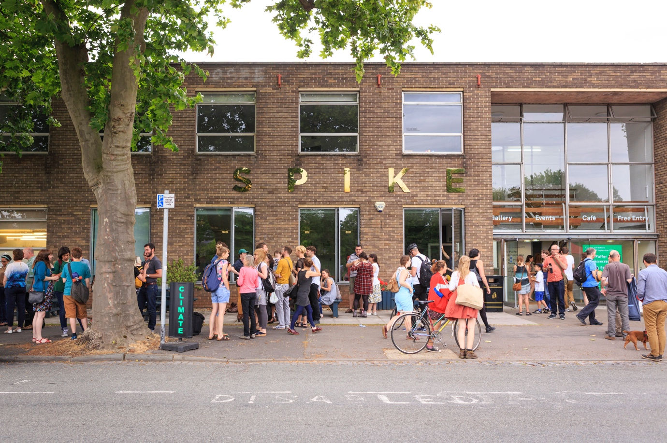
Image: Spike Island exterior. Photograph Max McClure
UWE Bristol / Spike Island Associates
Membership Bursary Application Form

As a soon-to-graduate student of a creative degree at UWE Bristol, you have the opportunity to apply for our Spike Island Associates Membership Bursary.

WHAT IS SPIKE ISLAND?
Spike Island is an international centre for the development of contemporary art and design. It is a place where artists and the public can meet, enabling audiences to engage with artists’ research and production. Spike Island offers visitors a year-round programme of internationally relevant exhibitions, events and activities, as well as providing working space for artists, designers and creative businesses. The link between the production and presentation of art on this scale and under one roof is unique within the UK. Spike Island’s programme emphasises the commissioning of new ambitious work and often provides artists their first significant gallery exhibition in the UK.

WHAT IS SPIKE ISLAND ASSOCIATES?
Spike Island Associates is a network that offers professional development opportunities to artists, curators, designers and writers who are keen to collaborate and experiment with all forms of art. Members are active contributors to a diverse network and support one another with ambitious projects, working individually or together to develop their own creative practice. To learn more about Spike Island Associates visit: https://www.spikeisland.org.uk/our-community/spike-island-associates/

WHAT IS THE BURSARY?
The standard Spike Island Associates membership fee is normally £12 per month.
UWE Bristol are offering to pay membership fees to the Spike Island Associates network for 16 months (a value of £192) for ten UWE Bristol graduates.

WHAT DOES A MEMBERSHIP INVOLVE?
As a member, you are encouraged to develop your own creative work and professional skills through practical workshops. A year-round programme of events, opportunities and projects is offered exclusively to members, including crit sessions with visiting artists from around the world. Spike Island Associates membership includes the following:

- Free admission to most of Spike Island’s talks and events
- 24-hour access to shared working space, featuring: IT facilities such as wireless internet, scanning, printing and computers with Adobe Suite, graphics and video editing software; a reference library including artists’ monographs, critical theory texts and art periodicals; and an active noticeboard for local, regional and national exhibitions, events and opportunities. (Please note that in response to the COVID-19 public health crisis access to the Associates Space is currently limited to 5 people at any one time.)
- Regular events, workshops, peer crits and one to one sessions with guest artists and curators
- Occasional group trips, with subsidised travel when possible
- The UWE Bristol / Spike Island Associate Membership Bursaries are valid for the 2021 intake from 30 September 2021 – 30 January 2023

CRITERIA
Applicants should be graduating from a UWE Bristol creative undergraduate programme in 2021.

The panel (comprising up to two members of staff from UWE Bristol and one member of staff from Spike Island) will select successful applicants using the following criteria:

- Demonstration of a commitment to the field of contemporary art, curating, writing and/or design.
- A clear understanding of how membership will enhance their professional practice.
- Clear articulation of a commitment to the city and / or region.
- The achievements of the applicant to date.
- The future creative potential of the applicant.

Successful applicants are expected to:

Complete a written evaluation when their membership ends comparing their progress against the original objectives outlined in their application form, as well as providing feedback to enable effective evaluation of the scheme.

COVID-19 – IMPACT ON SPIKE ISLAND ASSOCIATES PROGRAMME
The Associates programme is currently being delivered online, including one-to-ones with invited artists and curators, coaching sessions, consultations, reading groups, and workshop sessions. Access to the Associates Space is limited to 5 people at any one time.

UWE Bristol / Spike Associates Membership
Application Form

- Personal details

First name |  | Surname
Address
Phone |  | Mobile
Email
Website
UG UWE ACE degree programme
Degree classification

- Personal Statement

Please provide a short statement (up to a maximum of 300 words in total) on:

- An introduction to your practice and key areas of interest
- Why you feel that you would be a suitable candidate for this membership
- What contribution you could make and what you would hope to gain from it
- How this opportunity will enhance your professional development
- What you plan to focus on during the course of the membership

Please also give details of any other qualifications, training, experience or achievements to date that you consider to be relevant to your application.

- Please provide 5 digital images of your work at 300dpi in the format artistname_titleofwork.jpg, eg EdvardMunch_TheScream.jpg

I confirm I have included 5 digital images of my work 300dpi with my application ☐

Moving Image/performance

Alternatively, please provide links/URL’s for up to 5 pieces online. The panel will only consider a total run time of five minutes.

Link 1:
Link 2:
Link 3:
Link 4:
Link 5:

- Sign and date

I declare that the information I have given in this application form is, to the best of my knowledge, true and correct.

Signature Date / /

Please name your completed application form: Your Name_UWE Spike Associates Bursary Application.

Submit your completed application form and an equal opportunities monitoring form via the Spike Island website by Friday 28 May 2021.

Successful applicants will be notified by Wednesday 16 June 2021. Unfortunately, Spike Island cannot guarantee to provide individual feedback on unsuccessful applications.

