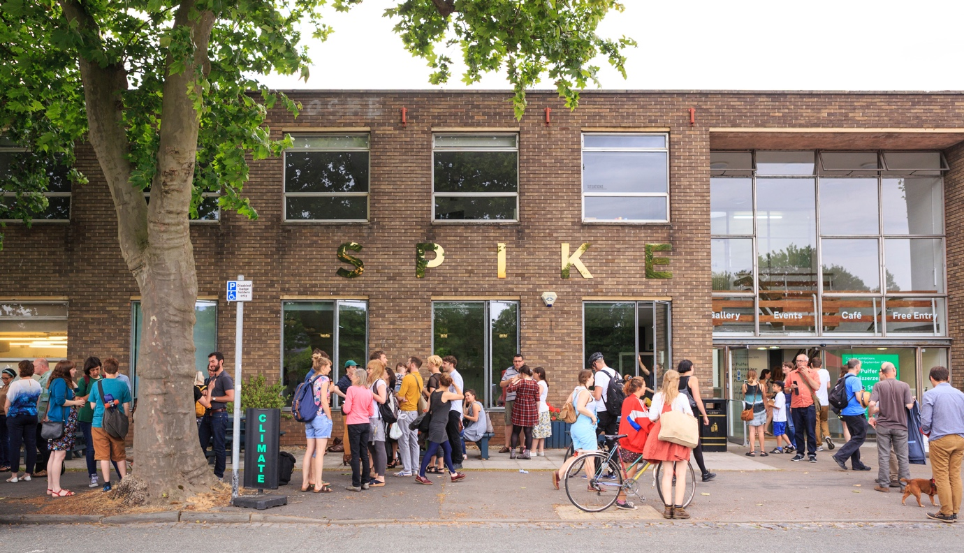
Image: The Spike Island building, photograph by Max McClure
UWE Bristol / Spike Associates
Membership Bursary Application Form

As a soon-to-graduate student of a creative degree at UWE Bristol, you have the opportunity to apply for our Spike Associates Membership Bursary.

Spike Island is a dynamic arts centre in Bristol that supports, produces and presents contemporary art and culture. It does this by engaging audiences through an exceptional artistic programme of large-scale exhibitions and interdisciplinary events; and directly supporting local and international artists and artist-led organisations through major new commissions, subsidised studio provision and critically-engaged artist development opportunities that widen access to its programme and facilities. In addition Spike Island provide bespoke exhibition services and are home to a café, workspaces for designers and creative businesses, and the UWE Bristol Fine Arts programme.

Spike Island Associates is a network of artists, curators, designers, writers and thinkers who are keen to collaborate and experiment with all forms of art. Members are active contributors to a diverse network, and supporting one another with ambitious projects, working individually or together to develop their own creative practice.

WHAT IS THE BURSARY?
The standard Spike Island Associates membership fee is normally £12 per month. UWE Bristol are offering to pay membership fees to the Spike Island Associates network for 16 months (a value of £192) for ten UWE Bristol graduates.

WHAT DOES A MEMBERSHIP INVOLVE?
As a member, you are encouraged to develop your own creative work and professional skills through practical workshops. A year-round programme of events, opportunities and projects are offered exclusively to members, including crit sessions and visiting artists from around the world. Spike Associates membership includes the following:

- Free admission to most of Spike Island’s talks and events.
- 24-hour access to shared working space, featuring: IT facilities such as wireless internet, scanning, printing and computers with Adobe Suite, graphics and video editing software; a reference library including artists’ monographics, critical theory texts and art periodicals; and an active noticeboard for local, regional and national exhibitions, events and opportunities. (Please note that in response to the COVID-19 public health crisis access to the Associates Space itself is currently limited to 5 people at any one time.)
- Regular events, workshops, peer crits and studio visits with visiting artists.
- Occasional group trips, with subsidised travel where possible.
- The UWE Bristol/Spike Island Associate Membership Bursaries are valid for the 2020 intake from 1 September 2020 – 31 August 2021.

CRITERIA
Applicants should be graduating from a UWE Bristol undergraduate programme in 2020.

The panel (comprising up to two members of staff from UWE Bristol and one member of staff from Spike Island) will select successful applicants using the following criteria:

- Demonstration of a commitment to the field of contemporary art, curating, writing and/or design.
- A clear understanding of how membership will enhance their professional practice.
- Clear articulation of a commitment to the city and/ or region.
- The achievements of the applicant to date.
- The future creative potential of the applicant.

SUCCESSFUL APPLICANTS ARE EXPECTED TO:

Complete a written evaluation when their membership ends comparing their progress against the original objectives outlined in their application form, as well as providing feedback to enable effective evaluation of the scheme.

COVID-19 IMPACT ON SPIKE ASSOCIATES PROGRAMME
The Spike Associates programme continues with minimal interruption, beyond limiting access to the Associates Space (maximum 5 people at any one time.) Much of the Associates core activity is currently delivered online, including one-to-ones with invited artists and curators, coaching sessions, consultations, reading groups and workshop sessions.

UWE Bristol / Spike Associates Membership Application

- Personal details

First name |  | Surname
Address
Phone |  | Mobile
Email
Website
UG UWE ACE degree programme
Degree classification

- Personal Statement

Please provide a short statement (up to a maximum of 300 words in total) on:

- An introduction to your practice and key areas of interest
- Why you feel that you would be a suitable candidate for this membership
- What contribution you could make and what you would hope to gain from it
- How this opportunity will enhance your professional development
- What you plan to focus on during the course of the membership

Please also give details of any other qualifications, training, experience or achievements to date that you consider to be relevant to your application.

- Please provide 5 digital images of your work at 300dpi in the format: artistname_titleofwork.jpg (for example: EdvardMunch_TheScream.jpg)

I confirm I have included 5 digital images of my work 300dpi with my application ☐

Moving Image/performance
Alternatively, please provide links/URL’s for up to 5 pieces online. The panel will only consider a total run time of five minutes.

Link 1:
Link 2:
Link 3:
Link 4:
Link 5:

- Sign and date

I declare that the information I have given in this application form is, to the best of my knowledge, true and correct.

Signature Date / /

Please name your completed application form: Your Name_UWE Spike Associates Bursary Application.

Submit your completed application form, and an equal opportunities monitoring form, via the Spike Island website by Friday 19 June 2020.

Successful applicants will be notified by Friday 3 July 2020. Unfortunately, Spike Island cannot guarantee to provide individual feedback on unsuccessful applications.

