SYLLABUS V
INFORMATION FOR APPLICANTS
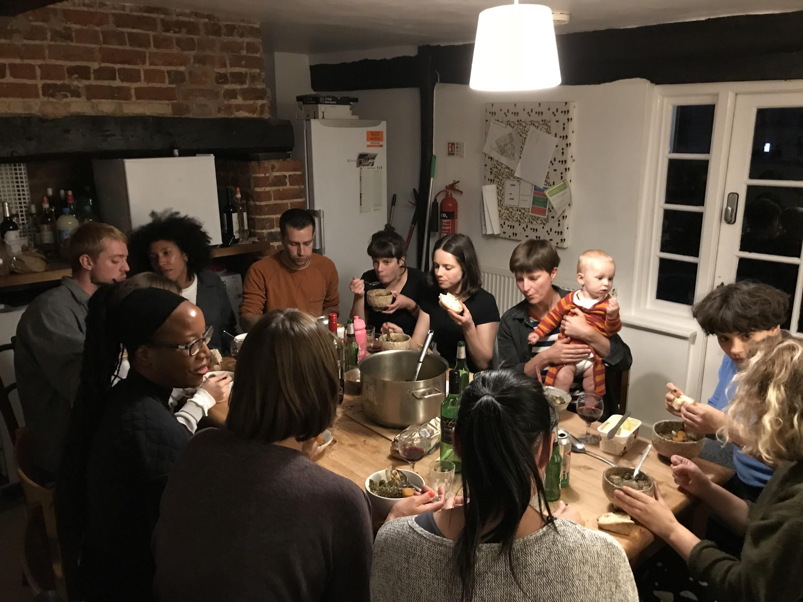

Wysing Arts Centre, Eastside Projects, Iniva, The NewBridge Project, S1 Artspace and Spike Island invite applications from artists for Syllabus V; a collaboratively produced alternative learning programme in its fifth year that will support ten artists across ten months.
Starting in September 2019, the curriculum for Syllabus V will be built around a series of seven intensive gatherings, which the ten selected artists, curators, partner organisations and two external Artistic Advisors will collaboratively develop. Syllabus V participating artists will bring forward ideas to the programme and actively contribute to its design and delivery across the ten months.
Syllabus V aims to reach artists with a range of practices and artistic approaches and bring together individuals from across the UK. We are particularly keen to support applicants who have not yet had access to similar programmes and artists with Black, Asian or minority ethnic heritage, those who are facing barriers due to difficult socio-economic situations, and artists who identify as LGBTQ+ or have disabilities. We ask applicants to make this clear when applying, if applicable.
PEOPLE
The individuals and organisations who will collaborate with the Syllabus V artists, and who will be involved across the ten months, are Ruth Claxton, Eastside Projects; Tavian Hunter, Melanie Keen and Simina Neagu, Iniva; Niomi Fairweather, Rebecca Huggan and Daniel Russell, The NewBridge Project; Laura Clarke, S1 Artspace; Elisa Kay, Spike Island; John Eng Kiet Bloomfield, Wysing Arts Centre. For Syllabus V, The NewBridge Project have joined as a guest partner. Two Artistic Advisors will be announced shortly.
Previous iterations of Syllabus have involved contributions from a wide range of artists, writers and curators and applicants to Syllabus V will have the opportunity to access similar networks. Contributing practitioners have included Larry Achiampong, Barby Asante, Ruth Beale, Marvin Gaye Chetwynd, Celine Condorelli, Nav Haq, Nadia Hebson, Anthea Hamilton, Andy Holden, Evan Ifekoya, Shama Khanna, Pil and Galia Kollectiv, Mark Leckey, Richard Long, Sofia Niazi, Katrina Palmer, Holly Pester, Rory Pilgrim, Morgan Quaintance, Tai Shani, Rosalie Schweiker, Cally Spooner, Richard Wentworth, Jonathan P. Watts, Keith Wilson, DM Withers, Rehana Zaman and Andrea Luka Zimmermann. We have received additional input and support from John Akomfrah, Benedict Drew, Kathy Noble, Eddie Peake, Marinella Senatore, Yinka Shonibare and Mike Sperlinger and have arranged visits to Documenta Athens and Glasgow International. Artists Sonya Dyer, Andy Holden, Milly Thompson, Jesse Darling, Harold Offeh and curators Helen Nisbet and George Vasey have led the Syllabus as Artistic Advisors in previous years, engaging with and supporting participating artists over the course of the programme.
PROGRAMME STRUCTURE
The programme will be structured around a series of gatherings at the partner venues which all participating artists will be required to attend. Some of these will last up to four days, whilst others may be shorter and they will be hosted in a variety of locations across the UK. During the first retreat, artists and individuals connected to the partner organisations and the Artistic Advisors will collaborate with participating artists to identify broad themes. They will collaboratively devise and structure a curriculum that will support individual and collective artistic development and provide access to networks and knowledge.
During periods between the gatherings, materials will be made available through a shared online resource, and the Artistic Advisors will support and advise participating artists through a series of planning sessions and 1-2-1 conversations over the course of the programme.
Artists will benefit from:
- The opportunity to collaboratively shape and develop a reflexive learning experience.
- The opportunity to develop supportive national networks of artists, curators and organisations.
- An intensive programme of gatherings at partner venues that offer time to come together to discuss ideas, work and approaches to practice.
- Introductions to, and connections with arts organisations, communities and networks in cities across the UK.
- Two focused 1-to-1 hour-long visits with the Artistic Advisors over the course of the year

PROGRAMME TIMETABLE*
*Note that these dates are currently provisional and are subject to change after further discussion with the participating artists
19–22 Sep 2019 - Wysing Arts Centre, Cambridgeshire
A four-day retreat, with onsite shared accommodation and food provided, that will introduce everyone who will be involved in Syllabus V to one another. Led by the Syllabus Artistic Advisors this gathering will enable selected artists, curators and programmers from the partner organisations, to come together, share practice and begin collaboratively planning the curriculum for Syllabus V.

1–3 November 2019 – Eastside Projects, Birmingham
6–8 December 2019 – The NewBridge Project, Gateshead
28 February – 1 March, 2020 – Spike Island, Bristol
24–26 April 2020 - S1 Artspace, Sheffield
5–7 June 2020 - Iniva, London
9–12 July 2020 - Wysing Arts Centre, Cambridgeshire

COSTS
Syllabus V costs artists £500 for the ten-month programme. There will be additional costs related to travel and accommodation, but sessions are planned well in advance to give time for participants to book low cost travel and accommodation.
The overall cost to deliver Syllabus V is £50,000 per year. The direct costs of delivering the programme are £23,000 of which £18,000 has been raised from Arts Council England and of which £5,000 is made up from fees from the ten participating artists. The remaining £27,000 is the contribution in-kind from the partner organisations to enable the programme to happen.
This year we are able to offer a bursary of £500 to provide a free place for a participating artist. Please indicate in your application if you would like to be considered for the bursary and outline your specific situation.
The partners are happy to write letters of support for participants who wish to make applications for professional development or travel grants.
Here are links to some funders who have supported previous participants:
- Arts Council England Developing Your Creative Practice
- Creative Scotland Open Project Funding
- Arts Council Wales
- Oppenheim-John Downes Memorial Trust

APPLICATION PROCESS
- Applicants should have been out of formal education for at least 4 years. We are also interested hearing from artists who have not progressed through formal art training routes.
- We aim to establish a cohort that represents a diversity of cultural perspectives and artistic practices and welcome applications from a wide geographic spread across the UK.
- We are looking for applicants who want to both develop their own work and actively contribute to the collaborative development of the curriculum for Syllabus V.
- Applicants are expected to make a significant contribution to shaping the programme and must be able to attend all gatherings and retreats.
- Syllabus V is open to artists based in the UK.
- Applications may be made via video or audio, to support those with dyslexia, rather than written form.
To apply, please provide:
- A statement describing why you would like to participate in Syllabus V (max 500 words);
- Initial ideas for contributors, themes or content; what this could bring to Syllabus V and why it is important to you and your work (max 500 words);
- A general statement on your work (max 500 words);
- A current CV;
- Information relating to your personal circumstances, if applicable. This might include information on your financial circumstances, your cultural background, your gender or sexuality, or details of any access needs;
- Please upload a selection of 10 images or a 5-minute showreel of relevant material. Please also provide links (vimeo/You Tube/soundcloud etc) to full length versions of audio-visual work and/or websites where additional visual material can be found.
- Applications must be made online at Submittable. Applications that are not made via this process will be ineligible.
Submittable link: https://wysingartscentre.submittable.com/submit/137992/syllabus-v
The deadline for applications is 12 midnight Monday 13 May. Interviews for The Syllabus will take place on 11, 12 and 13 June.
