Press release
New artists and advisors announced for Syllabus IV – an alternative collaboratively produced learning programme.
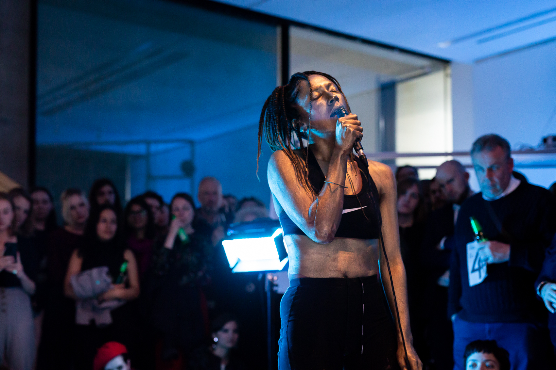
Image: Libita Clayton, I’m not my. My…..my injuries are healed now, but I still don’t remember things, Fledgling, Octavia. E. Butler, 2005, 2018. 30 minute performance, live sonic mapping in collaboration with Chris Boyd, Royal College of Art, London, UK. Image credit: Ollie Harrop

Ten artists have been selected for Syllabus IV, a national, collaboratively-produced alternative learning programme, jointly delivered by Wysing Arts Centre, Cambridge; Eastside Projects, Birmingham; Iniva (Institute of International Visual Arts), London; S1 Artspace, Sheffield; Spike Island, Bristol and Studio Voltaire, London.
The selected artists for Syllabus IV are: Scott Caruth, Libita Clayton, Jessica Coleman, Bettina Fung, Laura Hindmarsh, Beth Kettel, David Lisser, Alicja Rogalska, Kirsty Russell and Abigail Sidebotham.
Now in its fourth year, Syllabus IV provides a learning programme for artists over a ten-month period and is supported using public funding from Arts Council England.
Syllabus is developed collaboratively with the participating artists, the partner institutions and the artistic advisors, who this year are Sonya Dyer and Helen Nisbet.
The Syllabus IV artists work across a range of practices, from performance, filmmaking, sculpture and curation, researching diverse topics such as queer visibility, game show aesthetics, the post-colonial archive and the politics of food. They live and work across the UK including Pembrokeshire, Aberdeen, Tyneside, Nottingham, Cambridgeshire and London.
At the first retreat at Wysing in September 2018, Syllabus IV artists will come together to share their work and co-produce the year’s syllabus alongside the partners and artistic advisors. Beginning by presenting work and discussing shared concerns and problems, from the theoretical to the very practical, the group identify a list of aims for the year and a way of working that accommodates everyone. Meeting throughout the year, the cohort will invite guest artists, curators, writers and other practitioners to deliver intensive sessions hosted by each of the partners.
Previous contributors have included Barby Asante, Ruth Beale, Marvin Gaye Chetwynd, Céline Condorelli, Nav Haq, Anthea Hamilton, Andy Holden, Evan Ifekoya, Mark Leckey, Trevor Mathison, Katrina Palmer, Imran Perretta, Richard Wentworth and Rehana Zaman.
The full list of alumni and sessions from previous years of The Syllabus are available at http://www.wysingartscentre.org/archive/retreats
Resulting collaborations and opportunities have included #WePortal a live-stream event at the V&A; a week-long residency and group exhibition The Opposite of Now and Syllabus Mix a performance and screening evening, both held at Yinka Shonibare’s Guest Projects space in London; contributions to more of an avalanche, a group exhibition at Wysing Arts Centre; and solo exhibitions at Grand Union and Eastside Projects in Birmingham.
Abigail Sidebotham, one of the artists selected for this year's programme, commented: "For me, as an artist working in rural South West Wales and a as a new parent with a small baby to care for, the most valuable aspect of Syllabus IV is the time and space to connect with peers and arts professionals across the UK to engage in critical conversation and work collaboratively to make things happen. It's vital that artists are able to exchange their energies with one another and I'm excited to be able to take part in this valuable opportunity whilst meeting the needs of my son."
Laura Clarke, Curator at S1 Artspace said: "The selected artists this year represent a great breadth of practices and interests and are each at a point in their careers where Syllabus can provide a useful platform for sharing knowledge, building a strong peer network across the UK and the opportunity to reflect on and develop their ideas. Having just hosted a great weekend for Syllabus III at S1, including a walking tour with a social and cultural historian, a talk with artist Imran Perretta and a vocal facilitation workshop with musician Randolph Matthews, I can see the cross overs and divergences of Syllabus IV will make for a great curriculum. We're looking forward to collaborating with this exciting group!"
Helen Nisbet, Artistic Advisor said: “Syllabus is an important programme – unifying 6 art organisations and providing crucial support, collaborative opportunity and network for artists at pivotal points in their career. I'm very happy to be part of it, and am looking forward to being Artistic Advisor with Sonya Dyer, an artist whose work and approach I admire so much.”
For press information contact Nicola Jeffs – nicolajeffspr@gmail.com / 07794694754
Follow our activities at #SyllabusIV.

Notes to editors
Participating Artist Biographies
Scott Caruth
Scott Caruth is an artist based between Glasgow and Berlin. Recent exhibitions include Cazzate Su Cazzate at Glasgow International 2018 and Disco! An Interdisciplinary Conference at the University Of Sussex (2018). He is a founding member of Total Leatherette.
Libita Clayton
Libita Clayton is the recent recipient of the Freelands Artist Programme in association with Gasworks, London, UK (2018–19), and the Triangle Network Fellowship with the Bag Factory, Johannesburg, South Africa, (January–April 2018). Libita Clayton is based at Spike Island studios, Bristol, UK. She graduated with a BA (Hons) in Print & Digital Media from Wimbledon College of Art, University of the Arts London in 2009. Recent exhibitions and performances include: 4717, RCA/LUX, Dyson Gallery, Royal College of Art, London; Memento Mori, Kalashnikovv 3.0, Johannesburg, (all 2018); DEBUNK, Arnolfini, Bristol; Going Along Without a Body, Iklectik, London; History Lessons: Fluid Records, South London Gallery; Lexis Over Land – Towards a Feminist Geography, Tremenheere Sculpture Gallery, Cornwall; Diaspora Pavilion, 57th Venice Biennale; (all 2017); Gal-Dem WOC friday late, Victoria and Albert Museum, London; Beyond words, Book Works, Central Library, Freedom Festival, Hull, (all 2016).
Jessica Coleman
Jessica Coleman is a London-born multi-disciplinary artist. Working mainly in digital film and sculpture, Coleman’s work is a personal world, which is often humorous and surreal. It incorporates a wide range of medias and materials such as Snapchat, reality TV, beauty products, found objects, traditional gilding, plaster and silicone.
Her work plays on the line between desire and repulsion, real and fake, luxury and worthlessness, edible and poisonous. Questioning archetypal feminine ideals and how these are influenced by technology, the media, consumer industry and marketing.
Having grown up in a family working in the food industry, food and appetite are obsessions that constantly fuels her work. In her recent film Lunchtime Procedures, five women (all played by Coleman) meander through the meanings of their dreams around a red-hued dinner table, each eating a voluminous bowl of a technicolor soup. In recent sculptural work extruded blobs are casually dropped onto the surface of a luxurious silver-gilded mirror. The initial attractiveness, that of a tasty ‘sci-fi-patisserie’, collapses upon closer inspection, suggesting a more sinister undertone of base bodily forms and fluids.
Bettina Fung
Bettina Fung | 馮允珊 is a Hong Kong-born British-Chinese artist currently based in London. Drawing is at the core of Bettina’s artistic practice, which involves creating two-dimensional, performative and site-specific works. Her practice focuses on the performative aspect of drawing, where she draws in live settings at exhibitions and festivals. Sharing her process is an unfolding of something coming into being and she is drawn to this liminal space between nothing and existence that is potent with possibilities. Themes of ritual, liminality, transcendence, Taoist philosophy and more recently notions of productivity and progress are subjects of interest. Fung’s background is in computer animation, where she gained her degree in Bournemouth University (NCCA) in 2005 and previously studied computer science at The University of Bristol. She has exhibited nationally and abroad. She was a recipient of the a-n Artist Information Company's New Collaborations Bursary in 2014 to carry out collaborative research in combining traditional drawing methods with interactive design technologies. In 2018, she was awarded Arts Council England’s Grants for the Arts award in supporting her solo exhibition, Imprints of Passing Time, at Surface Gallery in Nottingham.
Laura Hindmarsh
Laura Hindmarsh lives and works between Australia and the UK. Her work is process led and interdisciplinary often interrogating its own mechanisms of production to the point of exhaustion or collapse. Working with processes of embodiment, repetition and layering, Hindmarsh highlights and questions established systems of representation.
Her work has been exhibited at the Art Gallery of New South Wales, Sydney; Centre for Contemporary Photography, Melbourne (both 2018); The Museum of Contemporary Art Australia, Sydney (2017); Contemporary Art Tasmania(2017); PhotoAccess, Canberra (2016); Standard Practice, New York (2015); Ve.Sch, Vienna; DARK MOFO Hobart (both 2013); and Perth Institute of Contemporary Art (2009); alongside showing moving image work at Alchemy Film and Moving Image Festival (2018), HOME Artist Film Weekender (2017); Edinburgh International Film Festival (2017); and the Contact Festival of Experimental Film and Video London (2016). She has undertaken studio residencies through Alchemy Film and Moving Image Festival (Morocco), Gorman Arts Centre (Canberra), Asialink (Kyoto), Cité Internationale des Arts (Paris), Bm:ukk in Residencie (Vienna), Big Fag Press (Sydney) and Contemporary Art Tasmania (Hobart). She is currently a studio artist at Wysing Art Centre.
Beth Kettel
Beth Kettel (born 1988 Leicestershire, lives and works in Nottingham and London) has recently presented solo exhibitions at Zabludowicz Collection: Invites, London (2017); Eastside Projects, Birmingham (2016); Two Queens, Leicester (2016); Hutt Gallery, Nottingham (2016) and Telfer Gallery, Glasgow (2015). Recent group shows and performances include Cob Gallery (curated by Joseph Bond), London (2018); Copperfield Gallery (curated by CACTUS), London (2018); Caustic Coastal, Manchester (2017); Jerwood Space, London (2016); (It's All) Tropical, Art Sheffield (2016).
David Lisser
David Lisser makes sculptures and installations that focus on food production, technology and the future. Recent projects have included The CleanMeat Revolution, an imagined retrospective of the 21st Century cultured meat industry (Watershed/wethecurious) and Last Ditch Attempt; a DIY mobile seed library in collaboration with Lucien Anderson (The Newbridge Project).
Alicja Rogalska
Alicja Rogalska is an artist living in London and working internationally. Her practice is research-led, interdisciplinary, collaborative and focuses on social structures and the political subtext of the everyday. She mostly works in specific contexts create situations, performances, videos and installations. Her projects attempt to practice a different political reality here and now, create space for many voices to be heard and to co-exist, whilst collectively searching for emancipatory ideas for the future. Alicja graduated with an MFA in Fine Art from Goldsmiths College and an MA in Cultural Studies from the University of Warsaw. She was artist in residence at MuseumsQuartier in Vienna (2018), IASPIS in Stockholm (2017), MeetFactory in Prague (2016), National University of Colombia in Bogota (2014), Tate Britain (2011-12), attended the Home Workspace programme at Ashkal Alwan in Beirut (2013–14) and was an Artsadmin Bursary recipient in London (2016-17).
Kirsty Russell
Kirsty Russell is an artist living and working in the North East of Scotland. Her practice is concerned with support and her relationship to it. Previous projects have been developed in response—noticing where something is lacking and working within those spaces. As a result, she has built a body of work that thinks about support structures in relation to artist practice as well as in places of care, hospitals and education —where she makes space, encourages and balances.
She studied at Gray’s School of Art and has undertaken residencies at Truck Contemporary Arts in Calgary and the Scottish Sculpture Workshop. Currently she is curating ‘Underpinning’, a programme of workshops at The Anatomy Rooms, Aberdeen.
Abigail Sidebotham
Abigail Sidebotham graduated from the Royal College of Arts in 2013 with an MA in Fine Art and has since exhibited internationally. Selected exhibitions and screenings include; HotShoe Gallery, UK, Altitude 1000+ Festival, Switzerland, DOX Centre for Contemporary Art, Czech Republic, Victoria Art Centre, Romania, CSU, Slovakia, Arti et Amicitiae, Holland, KASK, Belgium, Les Recontres International, Gallery Civica, Italy, FID Marseille and Whitechapel Gallery, UK.
In 2016 she delivered a year-long oral history and community project based on the Sea Empress oil spill that occurred off the coast of Pembrokeshire in 1996. The project saw the development of a collection of people's memories, film and photographs (now accessioned to National Library of Wales archives) and the production of a new artist film, which was exhibited during a solo exhibition at Oriel Myrddin, Carmarthen, UK (2018).
Artistic Advisor Biographies
Sonya Dyer
Sonya Dyer is an artist, writer and occasional curator. Her practice is performative, interdisciplinary and research-based utilising dialogical platforms, reproductive technologies and moving image. Dyer is concerned with modes of social organisation exploring how subjectivities and alliances are formed, particularly across cultures and temporalities. She has written for publications including Frieze, a-n online and Contemporary &. Recent projects include The Claudia Jones Space Station (BALTIC Centre for Contemporary Art and The NewBridge Project, Newcastle), Into the Future (Primary, Nottingham), At the Intersections (Nottingham Contemporary), Platform: In the Making and The Paul Robeson Research Station, (both Site Gallery, Sheffield). Dyer is a previous artsadmin Artist Bursary Scheme recipient and was a 2011–12 Whitney Museum of American Art: Independent Study Program Fellow.
Helen Nisbet
Helen Nisbet is a curator based in London. She was Curatorial Fellow at Cubitt where her exhibitions included solo shows by Mark Leckey, Helen Cammock and Flo Brooks and her events exploring writing, friendship and political defiance through readings, screenings and performance. She is a member of the Acquisitions and Advisory Committee for the Arts Council Collection, a Visiting Lecturer at the RCA, a she was a selector for Glasgow International 2018. Helen curates independent and collaborative projects across the UK and internationally including a new project with g39 in Cardiff and UK/ID an ongoing project by the British Council in Indonesia. She has also worked with organisations including Arts Council Collection, Creative Time, Open Source and the Contemporary Art Society.
Partners
Eastside Projects
Eastside Projects is an artist run multiverse, commissioning, producing and presenting experimental art practices and demonstrating ways in which art may be useful as part of society. Eastside Projects provides vital infrastructure, supports best practice and works to expand the role of the artist run space.
https://eastsideprojects.org/about/
Iniva
Iniva (Institute of International Visual Arts) is an evolving, radical visual arts organisation dedicated to developing an artistic programme that reflects on the social and political impact of globalisation.
http://www.iniva.org
S1 Artspace
S1 Artspace is a gallery and studio organisation based in Sheffield that actively supports the production and presentation of new work and ideas.
http://www.s1artspace.org/
Spike Island
Spike Island is an international centre for the development of contemporary art and design. A vibrant hub for production, presentation and debate, it invites audiences to engage directly with creative practices through participation and discussion.
http://www.spikeisland.org.uk/
Studio Voltaire
Studio Voltaire is one of the UK’s leading independent arts organisations. Studio Voltaire’s pioneering public programmes of exhibitions, participation projects, live events and offsite commissions have gained an international reputation for excellence.
http://www.studiovoltaire.org/
Wysing Arts Centre
Wysing Arts Centre is a registered charity that provides a range of programmes for artistic research, experimentation, discovery and production, out of which emerges an ongoing programme of exhibitions, public events, activity for young people, families and schools.
http://www.wysingartscentre.org

